**A Mini Project Report**

**On**

**ONLINE TOURIST GUIDE WEBSITE**

**Submitted By:**

**Aaryan Ojha**

**&**

**Pranav Malwatkar**

Academic Year: 2021– 2024



Shree Chanakya Education Society

**Indira College of Commerce and Science, Pune**

**Vice Principal & (H.O.D) Guided By**

**Prof. Shivendu Bhushan Prof. Sumit Sasane**

**Index**

|  |  |  |  |
| --- | --- | --- | --- |
| **Sr.No** |  | **Particular** | **Page No.** |
| **A)** |  | **Introduction** |  |
|  | **1)** | Title of Project |  |
|  | **2)** | Existing System |  |
|  | **3)** | Proposed System |  |
|  | **4)** | Advantages of proposed System |  |
|  | **5)** | Feasibility Study |  |
|  | **6)** | Hardware/Software Requirement |  |
| **B)** |  | **Analysis** |  |
|  | **1)** | ERD |  |
|  | **2)** | DFD |  |
|  | **3)** | CLD |  |
|  | **4)** | First Level DFD |  |
|  | **5)** | File Design / Normalized database |  |
|  | **6)** | Data Dictionary |  |
| **C)** |  | **Design** |  |
|  | **1)** | Input screen (Without Data) |  |
|  | **2)** | Input screen (With Data) |  |
| **D)** |  | **Code Design (Sample code)** |  |
| **E)** |  | **Limitations of System** |  |
| **H)** |  | **Bibliography** |  |

**Acknowledgement**

We would like to express our sincere and heartfelt gratitude to our institution” Indira College of Commerce and Science” which provided us with excellent opportunity to achieve our most cherished goal in life to become Bachelor degree in BBA(CA)

We are extremely grateful to our respected Vice Principal and HOD Prof, Shivendu Bhushan for providing excellent academic environment which has made this endeavour possible.

We take this opportunity to express our deep sense of gratitude to our guide Prof Sumit Sasane for their resplendent idea and constant encouragement in making this project unmitigated success. Their thoughtfulness and understanding was vast and thoroughly helpful in successful completion of project. Our sincere thanks to all our faculties and non-teaching staff for their at most co-operation.

Finally we proudly thank our parents and friends for their constant support and priceless guidance in throughout this endeavour.

Aaryan Ojha & Pranav Malwatkar

## A)Introduction :-

## 1) ONLINE TOURIST GUIDE WEBSITE

# * Overview Of Project :-

"Adventour" is the Online Tourism Information System, which is travel for recreational, leisure, family or business purposes, usually of a limited duration. Tourism is commonly associated with trans-national travel, but may also refer to travel to another location within the same country or internationally. Tourism has numerous tangible and intangible elements. Major tangible elements include transportation, accommodation and other components of a hospitality industry. Major intangible elements relate to the purpose or motivation for becoming a tourist, such as rest, relaxation, the opportunity to meet new people and experience other cultures, or simply to do something different and have an adventure. It attracts tourists for its historical forts, palaces, art and culture. Tourism is vital for all countries, due to the income generated by the consumption of goods and services by tourists, the taxes levied on businesses in the tourism industry, and the opportunity for employment and economic advancement by working in the industry. Due to India's rich history, its cultural and geographical diversity, makes it international tourism. We present heritage and cultural tourism along with transportation, packages, and various events of India via our websites.

**\*Objectives :-**

To develop a web based application, which includes-

1. To provide best travelling services to the customers.
2. To provide a search platform where a tourist can find their tour places according to their choices.
3. To promote responsible and interesting tourism so that people can enjoy their holidays at their favorable places.
4. To develop tourism with different cultures so that they enrich the tourism experience and build pride.
5. To create and promote forms of tourism that provide healthy interaction opportunities for tourists and locals and increase better understanding of different cultures, customs, lifestyles, traditional knowledge and believes.
6. To provide a better way to connect with various events.
7. To provide an easy and user friendly interface.

## 2) Existing System –

**\* Limitations:**

* User cannot book a tour package using this system.
* It may provide inaccurate results if data entered incorrectly.

## 3) Proposed System :

Our proposed tourism website is a comprehensive platform that aims to provide users with a seamless and personalized travel experience. The website offers a user-friendly interface with various features to assist users in planning their trips and exploring new destinations.

Users can create an account and log in to access personalized features. They can browse through a vast collection of destination information, including details about attractions, historical sites, local culture, transportation options, weather conditions, and recommended itineraries.

The website incorporates a robust search functionality with filters to help users find specific destinations, activities, or accommodations based on their preferences. Users can create their own trip itineraries by selecting destinations, attractions, and activities, and even receive suggestions based on their interests.

To facilitate accommodation booking, the website seamlessly integrates with hotel and accommodation booking platforms. Users can search for available accommodations, view details, compare prices, and make bookings directly through the website.

User reviews and ratings play a crucial role in the website's ecosystem. Users can leave feedback and ratings for destinations, accommodations, and activities they have experienced, assisting other users in making informed decisions.

The website also encourages social integration by allowing users to share their travel experiences and itineraries on popular social media platforms. Multi-language support is implemented to cater to international users, enabling them to switch between languages for a localized experience.

To provide excellent customer support, the website includes a feedback mechanism and offers assistance through various channels such as email, chat, or a dedicated support ticket system.

Overall, the proposed tourism website system aims to be a one-stop platform for travel enthusiasts, providing them with the necessary tools and information to plan, book, and explore their dream destinations efficiently and effectively.

**4) Advantages Of Proposed System :**

* Information on tourist attractions, cities, and provinces.
* Map and navigation system.
* Searching tours based on location.
* Offering/Booking tours.
* Ability to create a personal profile and keep a history of visited places.

**5) Feasibilty Study :**

Preliminary investigation examine project feasibility, the likelihood the system will be useful to the organization. The main objective of the feasibility study is to test the Technical, Operational and Economical feasibility for adding new modules and debugging old running system. All Customer query management system is feasible if they are unlimited resources and infinite time. There are aspects in the feasibility study portion of the preliminary investigation:

Technical Feasibility

Operational Feasibility

Economical Feasibility

**5.1. Technical Feasibility –**

The technical issue usually raised during the feasibility stage of the investigation includes the following:

✓ Does the necessary technology exist to do what is suggested?

✓ Do the proposed equipments have the technical capacity to hold the data required to use the new system?

✓ Will the proposed system provide adequate response to complains, regardless of the number or location of users?

✓ Can the complain management system for local government be upgraded if developed?

✓ Are there technical guarantees of accuracy, reliability, ease of access and data security?

The current system developed is technically feasible. It is a web based user interface. Thus it provides an easy access to the users. The database’s purpose is to create, establish and maintain a workflow among various entities in order to facilitate all concerned users in their various capacities or roles. Permission to the users would be granted based on the roles specified. Therefore, it provides the technical guarantee of accuracy, reliability and security. The software and hard requirements for the development of this project are not many and are available as free as open source. The work for the project is done with the current equipment and existing software technology. Necessary bandwidth exists for providing a fast feedback to the users irrespective of the number of users using the system.

**5.2. Operational Feasibility-**

Proposed projects are beneficial only if they can be turned out into information system. That will meet the organization’s operating requirements. Operational feasibility aspects of the project are to be taken as an important part of the project implementation. Some of the important issues raised are to test the operational feasibility of a project includes the following:

✓ Is there sufficient support for the management from the users?

✓ Will the system be used and work properly if it is being developed and implemented?

✓ Will there be any resistance from the user that will undermine the possible application benefits?

This complaint management system for local government project well-planned design would ensure the optimal utilization of the computer resources and would help in the improvement of performance status.

**5.3. Economical Feasibility –**

A system can be developed technically and that will be used if installed must still be a good investment for the government. In the economical feasibility, the development cost in creating the Complaint management system for local government project.

The system is economically feasible. It does not require any addition hardware or software. Since the interface for this system is developed using the existing resources and technologies available easily without any cost . There is nominal expenditure and economical feasibility for certain.

* **Security Feasibillity –**

Another important factor to be regarded is the security control, which is handled by the system. Since data regarding each complainant and government is confidential, security is a key issue. Information falling into the wrong hands could jeopardize the entire government. Unlike in un-computerized or semi-computerized systems ,the proposed system offers adequate control to protect the government against fraud and embezzlement and guarantees the accuracy and security of data and information. This is handled by the system providing individuals with separate login names ans passwords.

**6) Hardware & Software Requirements :**

**Software Requirements:**

* Windows 7 or higher.
* SQL 2008
* Visual studio 2010

**Hardware Components:**

* Processor – i3
* Hard Disk – 5 GB
* Memory – 1GB RAM
* Internet Connection

## B)Analysis :-

## 1) ERD:

user

Admin

Handles

Makes

does

Payment

enquiry

m

m

1

does

Booking

m

m

m

m

## 2) DFD:

DFD is the abbreviation for Data Flow Diagram. The flow of data of a system or a process is represented by DFD. It also gives insight into the inputs and outputs of each entity and the process itself. DFD does not have control flow and no loops or decision rules are present. Specific operations depending on the type of data can be explained by a flowchart.

## 3) Context Level DFD:

Online

T

ourism

stem

y

s

Admin

Admin

User

User

**0.0**

Query

Report

Access

Response Details

Acknowledgement

Login

T

ourism Details

Payment

## 4) First Level DFD:

Master

Generation

Process

Admin

**1.0**

User Details

Booking

Payment Details

Booking Details

Booking

User Details

User

Payment

Search

Enq

uiry

Process

**3.0**

Booking

User

Destination

T

ourismdetails

T

ourisum

Details

g

Lo

in

Process

Admin

**2.0**

Username

and Password

Access

Login

User

User

Username

and Password

Access

Username

and Password

Username

and Password

g

Bookin

Process

**4.0**

Booking

User

Booking

Confirmation

T

ourisum

Booking

Details

T

ourism

Details

User

**5.0**

Booking

Payment

Booking

Details

Payment

Payment

Details

Payment

Acknowledgement

Payment

Process

Admin

**6.0**

Login

Details

Query

Report

Report

Generation

Process

Login

Booking

Payment

Enquiry

Booking

Details

Payment

Details

Enquiry

Details

**5) File Design / Normalized Database :**

**Table Name –**

|  |  |  |  |  |
| --- | --- | --- | --- | --- |
| **Sr No.** | **Field Name** | **Datatype** | **Width** | **Constraint** |
| 1 | ID | INT | 11 | Primary Key |
| 2 | UserName | VARCHAR | 25 | Not Null |
| 3 | Email | VARCHAR | 25 | Not Null |
| 4 | Password | VARCHAR | 25 | Not Null |
| 5 | question1 | VARCHAR | 66 | Not Null |
| 6 | question2 | VARCHAR | 66 | Not Null |
| 7 | IsAdmin | TINYINT | 1 | Not Null |

**Table Name –payment**

|  |  |  |  |  |
| --- | --- | --- | --- | --- |
| **Sr No.** | **Field Name** | **Datatype** | **Width** | **Constraint** |
| 1 | id | INT | 4 | Primary Key |
| 2 | Full_Name | VARCHAR | 35 | Not Null |
| 3 | Email | VARCHAR | 35 | Not Null |
| 4 | Address | VARCHAR | 35 | Not Null |
| 5 | City | VARCHAR | 35 | Not Null |
| 6 | State | VARCHAR | 35 | Not Null |
| 7 | Zip | INT | 35 | Not Null |
| 8 | Card_Name | VARCHAR | 35 | Not Null |
| 9 | Card_Number | VARCHAR | 35 | Not Null |
| 10 | Expmonth | VARCHAR | 35 | Not Null |
| 11 | Expyear | VARCHAR | 35 | Not Null |
| 12 | Cvv | VARCHAR | 35 | Not Null |

**Table Name –Enquiries**

|  |  |  |  |  |
| --- | --- | --- | --- | --- |
| **Sr No.** | **Field Name** | **Datatype** | **Width** | **Constraint** |
| 1 | id | INT | 4 | Primary Key |
| 2 | Frist_name | VARCHAR | 35 | Not Null |
| 3 | Last_Name | VARCHAR | 35 | Not Null |
| 4 | Email | VARCHAR | 35 | Not Null |
| 5 | Message | VARCHAR | 35 | Not Null |

**Table Name –bookdetails**

|  |  |  |  |  |
| --- | --- | --- | --- | --- |
| **Sr No.** | **Field Name** | **Datatype** | **Width** | **Constraint** |
| 1 | id | INT | 4 | Primary Key |
| 2 | email | VARCHAR | 35 | Not Null |
| 3 | destination | VARCHAR | 55 | Not Null |
| 4 | adults | VARCHAR | 35 | Not Null |
| 5 | children | VARCHAR | 35 | Not Null |
| 6 | price | INT | 35 | Not Null |
| 7 | total | DECIMAL | 10,2 | Not Null |

**C)Design :-**

**I. Input Screen (With Data):**

1. User SignUp –

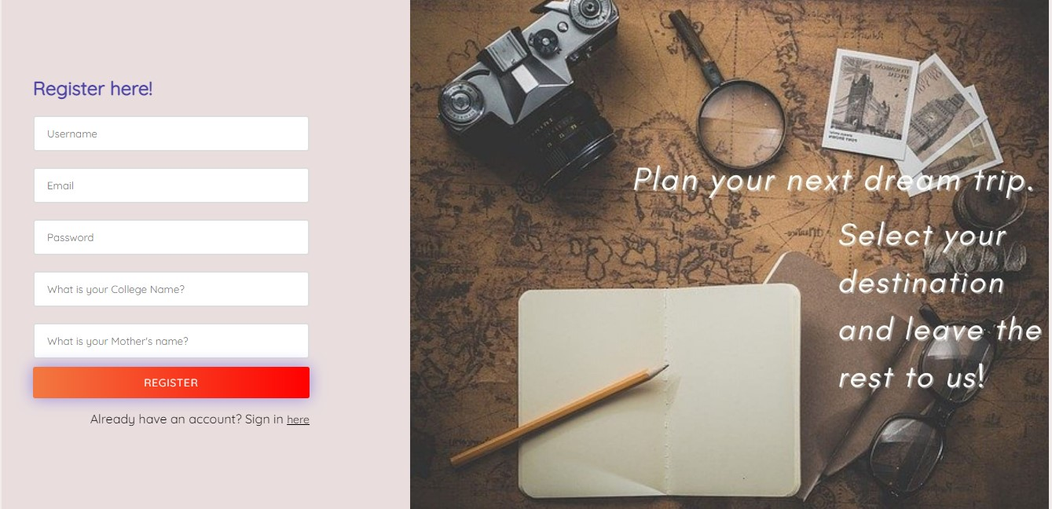

1. User : Forgot Password –

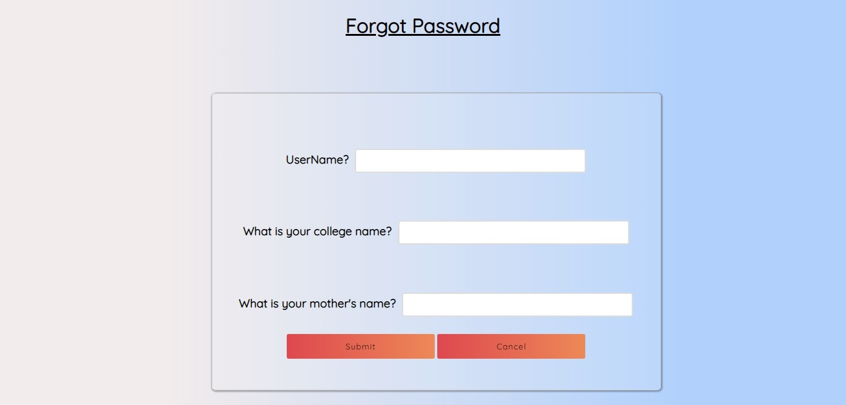

3) User Login –

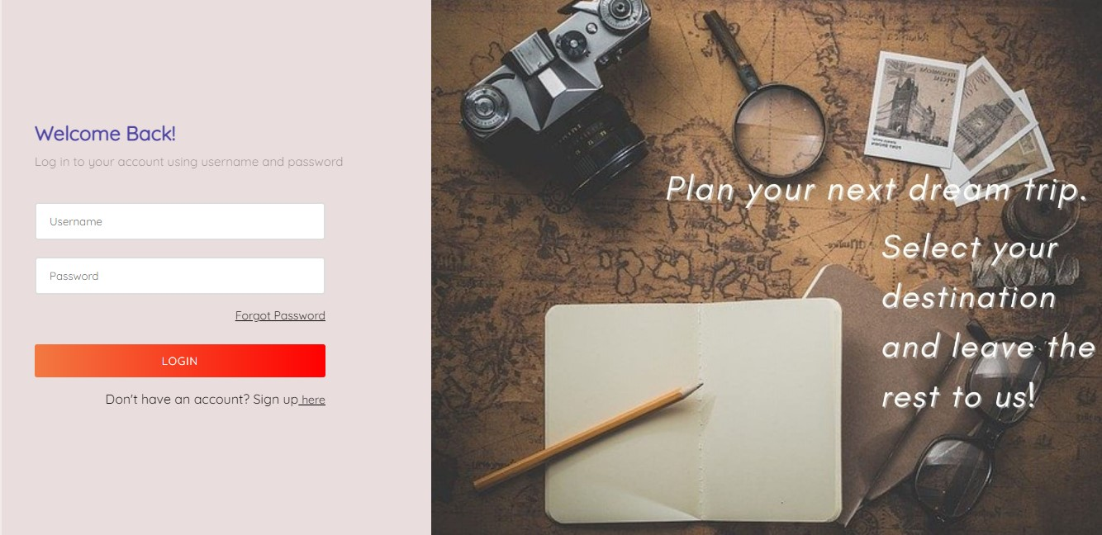

4)User Homepage-

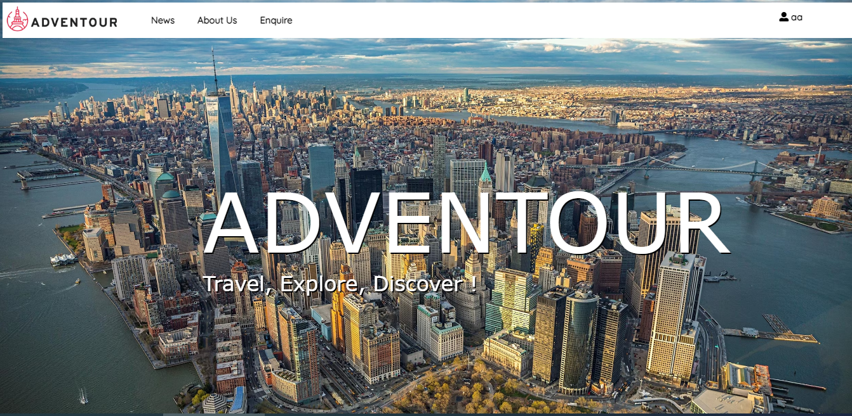

5)User Profile-

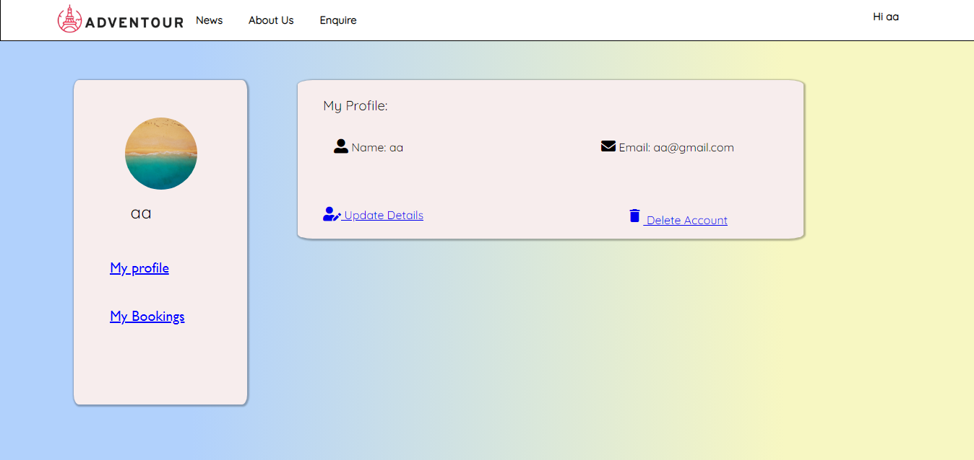

6)Admin Homepage-

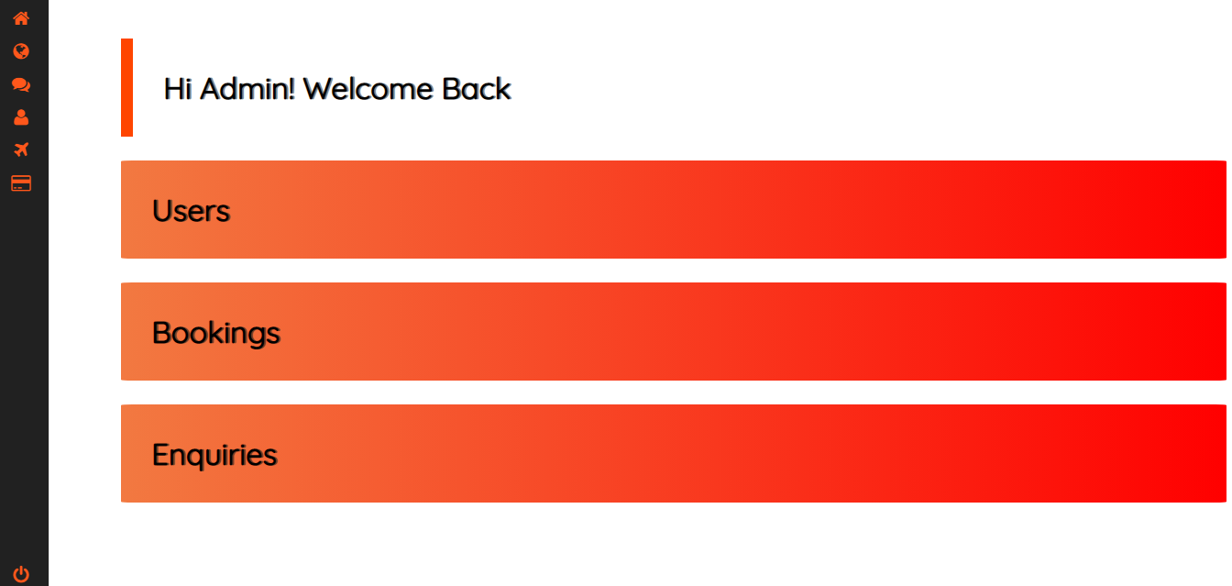

7)Admin-Destination/Packages-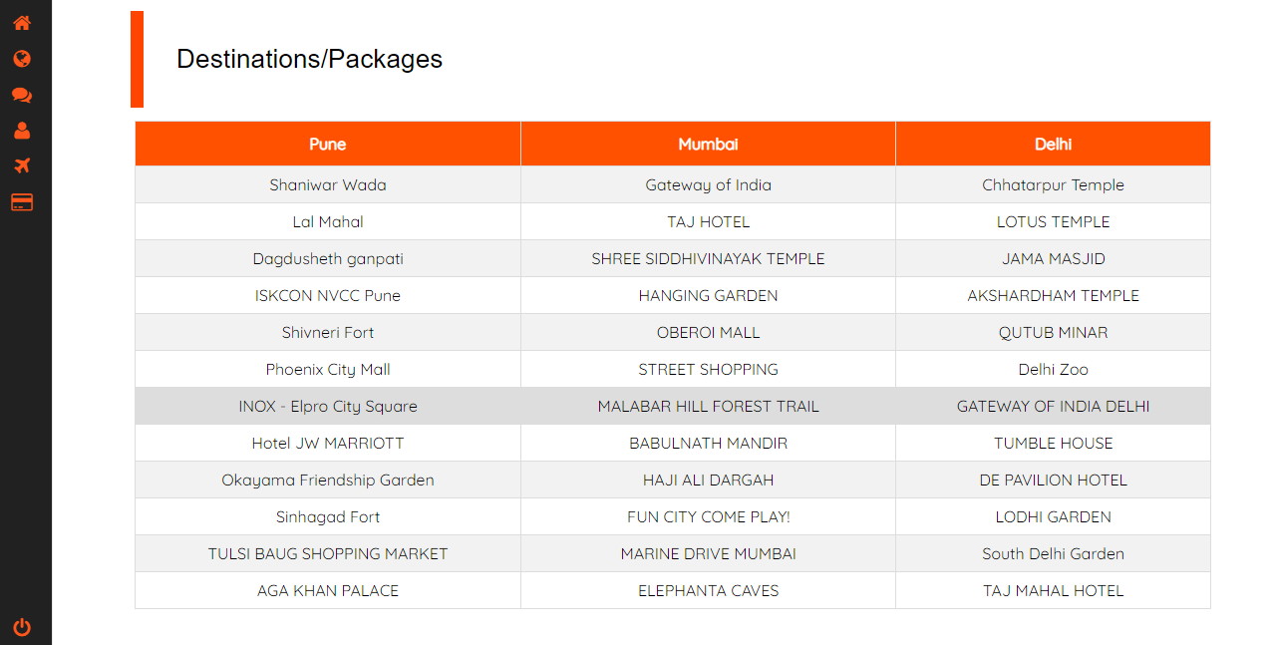

8)Admin Details-

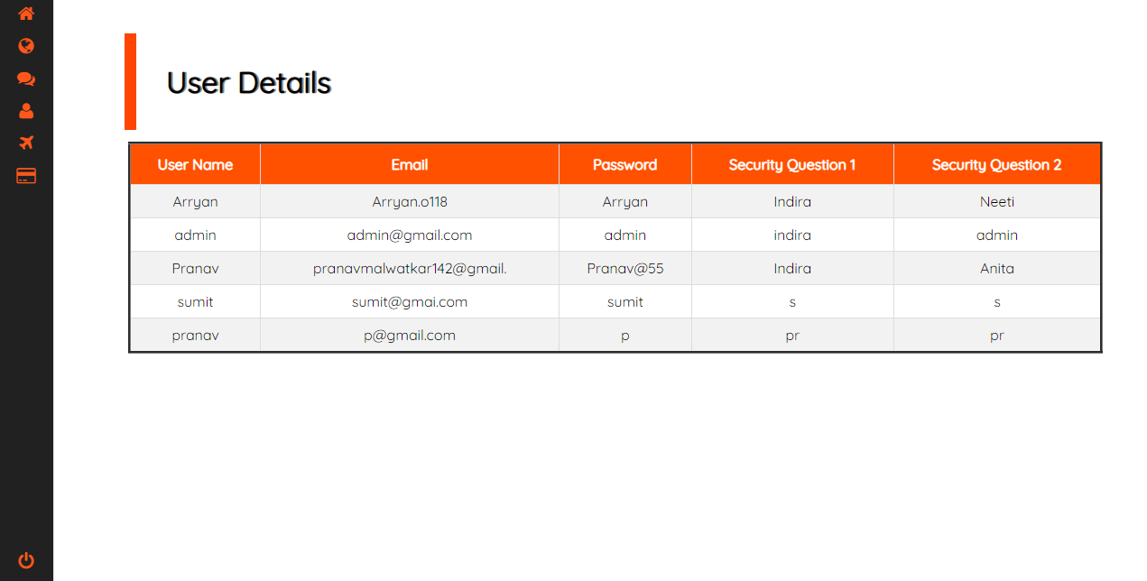

9)Admin-Bookings-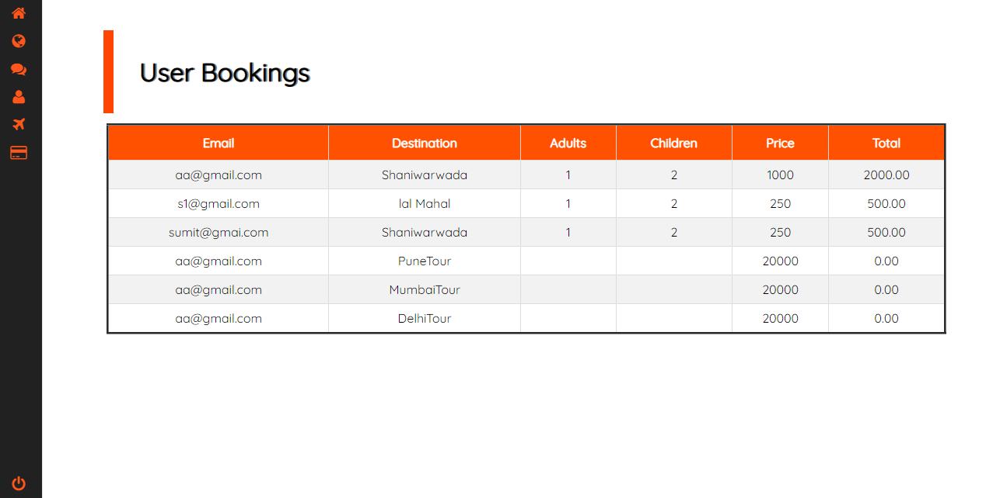

10)Admin-Report- -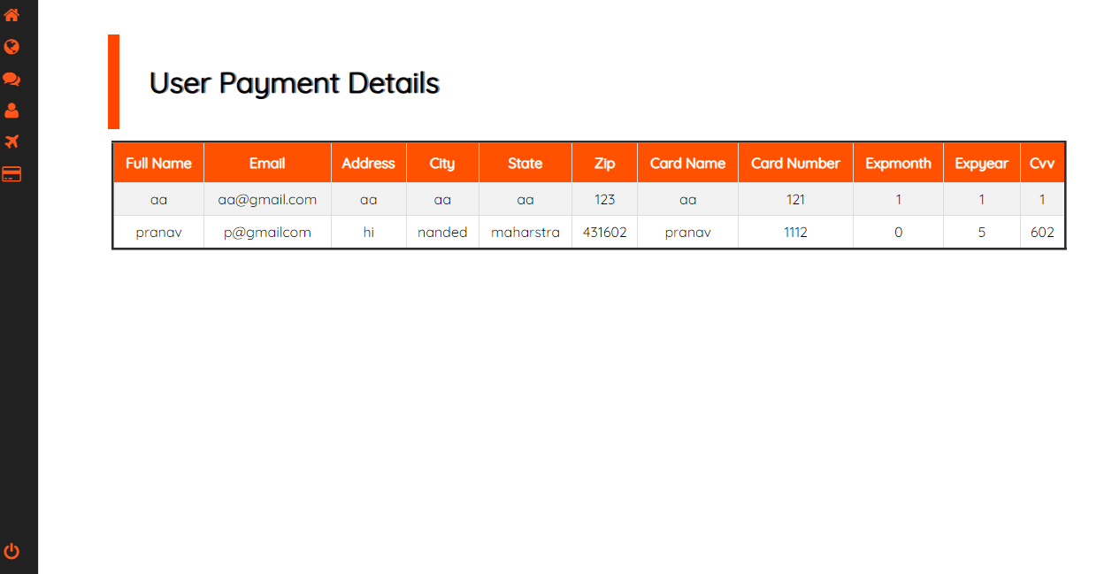

12)Tourisum First Page-

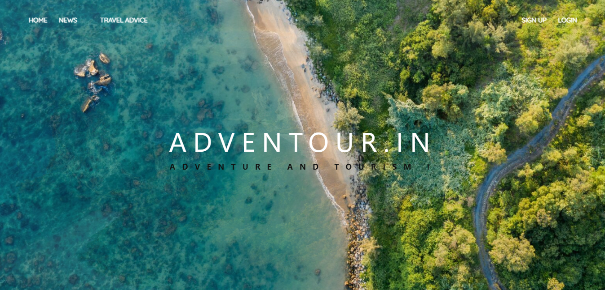

13) Package Booking:

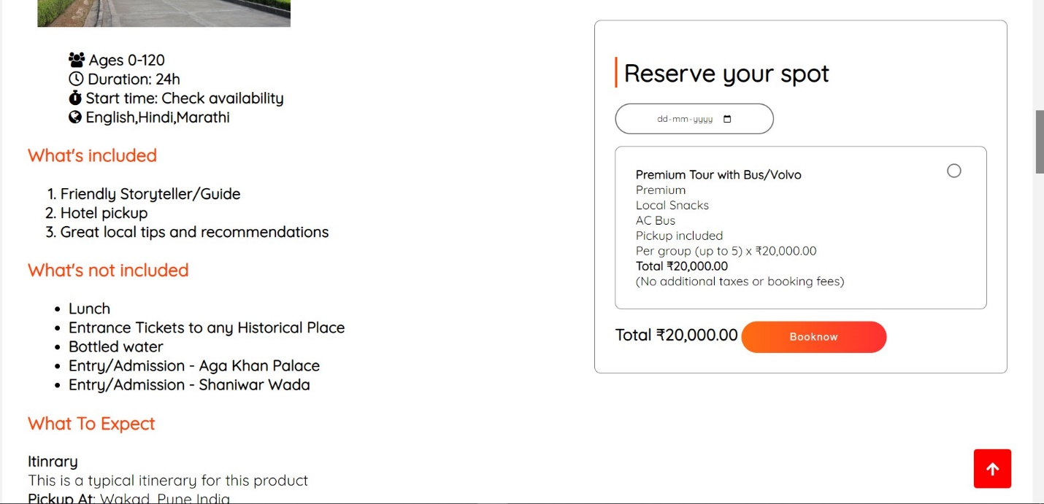

14) Individual Booking:

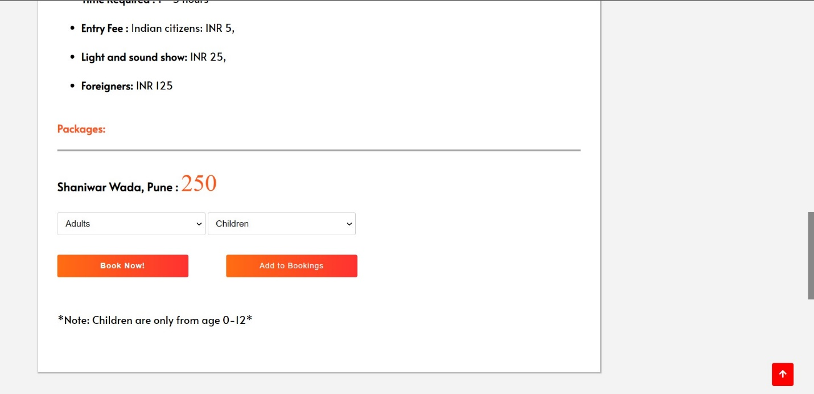

**D) Sample Code :-**

**View Login Code –**

<html>

  <head>

    <link rel="stylesheet" href="../Login/demo.css" type="text/css" />

  </head>

  <form method="POST" action="../Database/database.php">

    <div class="container">

      <div class="left">

        <div class="header">

          <h2 class="animation a1">Welcome Back!</h2>

          <h4 class="animation a2">

            Log in to your account using username and password

          </h4>

        </div>

        <div class="form">

          <input

            type="username"

            class="form-field animation a3"

            placeholder="Username"

            name="u"

          />

          <input

            type="password"

            class="form-field animation a4"

            placeholder="Password"

            name="p"

          />

          <p class="animation a5">

            <a href="../Login/forgot.html">Forgot Password</a>

          </p>

          <button class="animation a6" name="login">LOGIN</button>

          <p class="animation a6">

            Don't have an account? Sign up<a href="../Login/signup.html">

              here</a

            >

          </p>

        </div>

      </div>

      <div class="right"></div>

    </div>

  </form>

</html>

**View signup Code –**

<html>

  <head>

    <link rel="stylesheet" href="../Login/demo.css" type="text/css" />

  </head>

  <form method="POST" action="../Database/registerdb.php">

    <div class="container">

      <div class="left">

        <div class="header">

          <h2 class="animation a1">Register here!</h2>

        </div>

        <div class="form">

          <input

            type="username"

            class="form-field animation a3"

            placeholder="Username"

            name="uname"

          />

          <input

            type="email"

            class="form-field animation a4"

            placeholder="Email"

            name="email"

          />

          <input

            type="password"

            class="form-field animation a5"

            placeholder="Password"

            name="pass"

          />

          <input

            type="text"

            class="form-field animation a6"

            placeholder="What is your College Name?"

            name="q1"

          />

          <input

            type="text"

            class="form-field animation a6"

            placeholder="What is your Mother's name?"

            name="q2"

          />

          <button class="animation a6" name="register">REGISTER</button>

          <p class="animation a5">

            Already have an account? Sign in

            <a href="../Login/login.html">here</a>

          </p>

        </div>

      </div>

      <div class="right"></div>

    </div>

  </form>

</html>

**View Database Code –**

<?php

// Check if the login form was submitted

if (isset($_POST["login"])) {

    // Get the username and password from the form

    $UserName = $_POST["u"];

    $Password = $_POST["p"];

    // Connect to the database

    require_once "../Database/functions.php";

    $conn = DBConnect();

    if (!empty($UserName) && !empty($Password)) {

        // // Query the database to check if the user exists

        $query = "SELECT * FROM users WHERE UserName='$UserName' AND Password='$Password'";

        $result = mysqli_query($conn, $query);

        // Check if the query was successful

        if ($result && mysqli_num_rows($result) > 0) {

            $row = mysqli_fetch_assoc($result);

            $IsAdmin = $row["IsAdmin"];

            // Start the session

            session_start();

            // Create a session object

            $sessionObject = new stdClass();

            $sessionObject->name = $UserName;

            $sessionObject->email = $row["Email"];

            $sessionObject->isAdmin = $isAdmin;

            $sessionObject->pwd = $Password;

            // Save the session object

            $_SESSION["mySessionObject"] = $sessionObject;

            if ($IsAdmin) {

                header("Location:../../Admin/admin.html"); // Redirect to dashboard page

            } else {

                header("Location:../Homepage/homepage.php"); // Redirect to dashboard page

            }

        } else {

            // User doesn't exist or wrong password

            echo "<script> alert('Invalid Username or Password !');

            window.location.href='../Login/login.html';

            </script>";

        }

    } else {

        echo "<script> alert('Invalid input !');

        window.location.href='../Login/login.html';

        </script>";

    }

}

?>

**View Registerdb Code –**

<?php

if (isset($_POST['register'])) {

  // Check if the email already exists in the database

  $UserName = $_POST['uname'];

  $Email = $_POST['email'];

  $Password = $_POST['pass'];

  $question1 = $_POST['q1'];

  $question2 = $_POST['q2'];

  $IsAdmin = 0;

  //Connect to the MySQL database

  require_once('../Database/functions.php');

  $conn = DBConnect();

  if (

    !empty($UserName) && !empty($Email) && !empty($Password) && !empty($question1) && !empty($question2)

  ) {

    if (mysqli_connect_error()) {

      die('Connect Error(' . mysqli_connect_error() . ')' . mysqli_connect_error());

    } else {

      $SELECT = "SELECT Email From users Where Email=? Limit 1";

      $INSERT = "INSERT Into users(UserName,Email,Password,question1,question2,IsAdmin) values(?,?,?,?,?,?)";

      //prepare statement

      $stmt = $conn->prepare($SELECT);

      $stmt->bind_param("s", $Email);

      $stmt->execute();

      $stmt->bind_result($Email);

      $stmt->store_result();

      $rnum = $stmt->num_rows;

      // var_dump($rnum);

      if ($rnum == 0) {

        // Start the session

        session_start();

        // Create a session object

        $sessionObject = new stdClass();

        $sessionObject->name = $UserName;

        $sessionObject->email = $Email;

        // Save the session object

        $_SESSION['mySessionObject'] = $sessionObject;

        $stmt->close();

        $stmt = $conn->prepare($INSERT);

        // var_dump($stmt);

        $stmt->bind_param("sssssi", $UserName, $Email, $Password, $question1, $question2, $IsAdmin);

        $stmt->execute();

        echo "<script>

        alert('Account Created Successfully!');

        window.location.href='../Homepage/homepage.php';        </script>";

      } else {

        echo "<script>

        alert('Someone already registered using this email.');

        window.location.href='../Login/signup.html';

        </script>";

      }

      $stmt->close();

      $conn->close();

    }

  } else {

    echo "<script>

    alert('Invalid Input');

    window.location.href='../Login/signup.html';

    </script>";

  }

}

?>

**E) Limitations Of System :-**

1. Limited Information: Our website has limited space to provide comprehensive information about a destination. Hence we may not be able to cover all the attractions, accommodations, dining options, and activities available, leaving users with an incomplete picture.
2. Static Content: Our website is corrently static and do not offer real-time updates. This means that the information displayed, such as opening hours, availability, or pricing, may not be up to date. Users may need to verify the information through other channels.

**F) Future Enhancements**

1. Making the GUI more user friendly.
2. Enhancing the performance.
3. Adding some new features like user photo gallery.
4. Adding real time updates for better personalization.
5. Fixing the problem of limited information.

**G) Bibliography**

* **Web References:**

1. <https://www.w3schools.com/>
2. <https://pune.gov.in/tourist-places/>
3. https://tourism.gov.in/